Identify this component 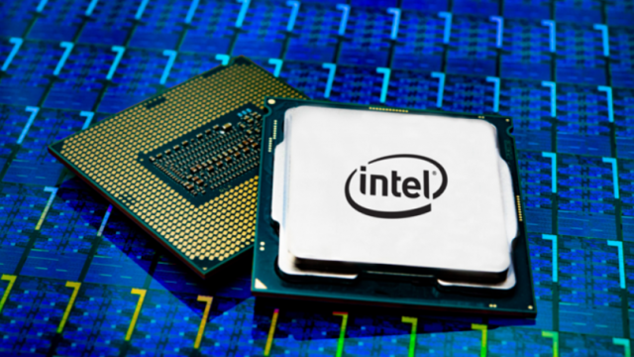 ---

(1 mark)

Describe the use of a gpu and give an example of a case it would be required ---

(3 mark)

Explain the difference between ram and rom ---

(2 mark)

The component that can store long term memory in mark’s computer has been destroyed, please specify which component it is ---

* Cpu
* Gpu
* HDD
* RAM
* Power supply

(1 mark)

Is an apu better than a cpu? Justify your reasons ---

(3 mark)